Blue Ridge Mountain Sports Car Club Steel Cities Region, SCCA
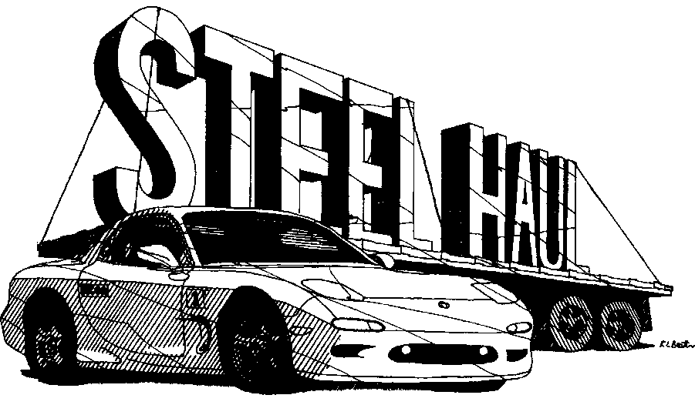

The Steel Haul is a 175 mile route on paved and unpaved roads to Armstrong County. It features LRIs, NRIs, and changing MRDs. Open Controls and DIYCs are used to test contestants’ thorough understanding of the general instructions. The course is not fast; course following is the challenge. Scenery in the area is superb with many streams, valleys and beautiful vistas.

NATIONAL COURSE RALLY, SATURDAY, APRIL 30, 2022
& the
IRON RUN
DIVISIONAL COURSE RALLY, SUNDAY, MAY 1, 2022
The Iron Run is a 100 mile trip on paved and unpaved roads in Armstrong County.
SCHEDULE:
Registration - Friday April 29, 2022, 6:00PM to 9:00PM. Arrangements for late registration must be made in advance to the chairman at Carl@Sky-Pro.com | Steel Haul | Iron Run
Route Instructions issued to Car #1 | 7:31 AM | 8:01 AM
Car #1 starts rally | 8:01 AM | 8:31 AM
Car #1 arrives at lunch break (approx.) | 12:30 PM | ---
Car #1 finishes rally (approx.) | 5:00 PM | 1:00 PM
Trophies awarded (or sooner) | 6:30 PM | 2:00 PM
RALLY COMMITTEE:
Chairman: Carl Staab 412-327-7524, Carl@Sky-pro.com Steel Haul/Iron Run Rallymaster: Chuck Larouere 412-855-8379, refdesignpit@comcast.net
HEADQUARTERS:
Event headquarters is the Days Inn, 6 Landings Dr., Pittsburgh, PA 15238. For reservations call 412-828-5400 and mention SCCA to get the event rate of $69.99.
ENTRY FEES:
SCCA members for Steel Haul: $90.00 & $60 for Iron Run. Entries must be received by April 25th, 2022. Car numbers will be drawn and General Instructions mailed on April 16th. Add $15 for non-members Weekend Membership.

STEEL HAUL & IRON RUN
ENTRY FORM
April 30 & May 1, 2022

CONTESTANT INFORMATION

Driver:
Address:
City/State/Zip:
Phone:
E-mail Address:
SCCA Member
No. & Region:
Minor (age 18 or under)? Yes No
Navigator:
Address:
City/State/Zip:
Phone:
E-mail Address:
SCCA Member
No. & Region:
Minor (age 18 or under)? Yes No

All official correspondence will be sent by email.

ENTRY INFORMATION

Steel Haul National Course Rally

Class: Equipped Limited Stock GPS
Entry Fee: $90 SCCA members

Iron Run Divisional Course Rally
Class: Equipped Limited Stock GPS
Entry Fee: $60 SCCA members

Non members add $15 for a Weekend Membership

Mail completed entry form with a check payable to “BRMSCC” to:
Carl Staab
4310 Sardis Rd.
Murrysville, PA 15668

Entry must be received by April 25th, 2022

VEHICLE INFORMATION
Make Model Year Color
License # State Does either competitor own this vehicle? Yes No

We warrant that the vehicle is on the road legally and is being used by the entrants with the owner’s permission.
The entrant warrants that an auto insurance policy in conformity with Article 14.C is in force for each vehicle entered.

Driver signature Date

Navigator signature Date

